Lytic Solutions, LLC
1202 Ann Street
Madison, WI 53713
Fritz.Schomburg@LyticSolutions.com
Phone: (608) 345-8848
Fax: (866) 281-9243

Recombinant T4 ligase
Lot F151-018-020

MW: 56.2 K

Purity: >95% (SDS-PAGE)

Size: 1 ml

Activity: 2,000,000 U/ml

Storage buffer: 10 mM Tris-HCl (pH 7.4), 50 mM KCl, 0.1 mM EDTA, 1 mM DTT and 50% glycerol

Storage: -20°C

Reaction buffer (x1): 50 mM Tris-HCl (pH 7.5), 10 mM MgCl₂, 10 mM DTT and 1 mM ATP

Quality control assays:

Endonuclease activity: not detected after incubation with pUC19 RF1 at 37°C for 1 hour

Exonuclease activity: <0.1% white colonies in blue/while assay using pUC19 with 5' overhangs, 3' overhangs or blunt ends

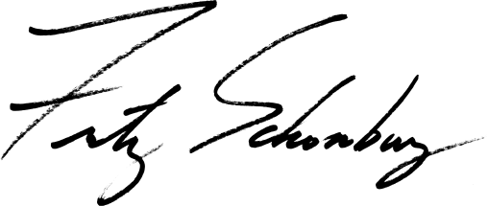
Fritz Schomburg, PhD

