Lytic Solutions, LLC
1202 Ann Street
Madison, WI 53713
Fritz.Schomburg@LyticSolutions.com
Phone: (608) 345-8848
Fax: (866) 281-9243

Certificate of Analysis

Recombinant Protein G
Product Number: LS1563-rPG  Lot Number:019-008-1B  Date of manufacture: Dec 5, 2013 |  | Product No:  Lot No:  Date of Manufacture:

Quality Control:

rProtein G has been functionally tested and has met the following specifications:
Purity: > 95% by Coomassie PAGE.
Molecular Weight: 23.2 kDa (LS1563) by mass spectrometry, apparent running mass is approximately 33kDa.
rProtein G Activity: Greater than 99% binding to immobilized rabbit IgG as measured by coomassie PAGE.
Results: Passes specifications.

For Research Use Only. Not for Human or diagnostic Use. If you have any further questions about this Certificate of Analysis, please contact Lytic Solutions at (608) 345-8848.

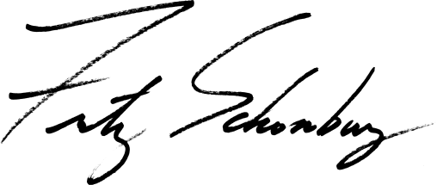
Fritz Schomburg, PhD
Founder and CEO

Lytic Solutions, LLC
1202 Ann Street
Madison, WI 53713
Fritz.Schomburg@LyticSolutions.com
Phone: (608) 345-8848
Fax: (866) 281-9243

Datasheet: His-Streptavivin – LS1909B
Description | E. coli derived recombinant His-Streptavidin is made from the streptavidin gene from Streptomyces avidinii. LS1909B is a tetramer and each monomer contains a His-Tag.  • Greater than 98% streptavidin is present in tetramer formation, assayed by non-heat denatured SDS PAGE.  • Biotin-binding activity: >16 U/mg (Green’s modified assay)  • His-tag binding efficiency: complete protein retention on NTA resin | 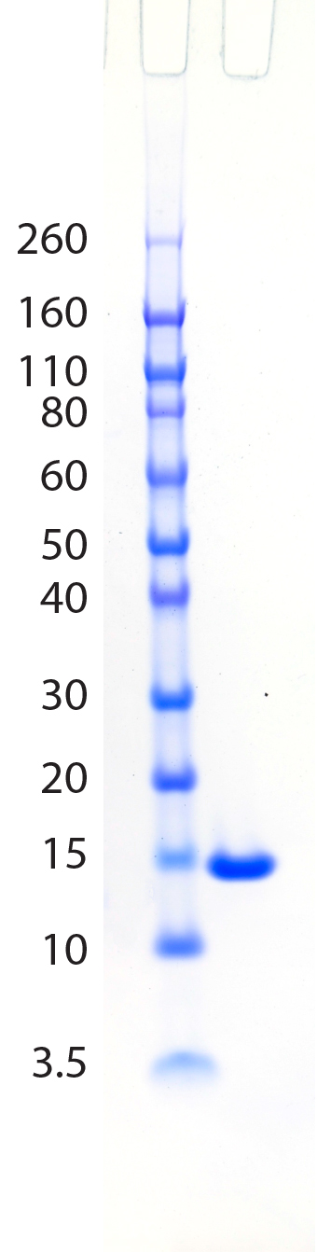  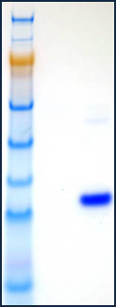  Figure 1. Purity and activity analysis of recombinant His-tagged streptavidin by SDS PAGE.  2  1  M  kDa  14  17  28  38  49  62  98  188  2  1  M  kDa  14  17  28  38  49  62  98  188  2  1  M  kDa  14  17  28  38  49  62  98  188  Purified His-Streptavidin was analyzed on a Life Technologies Novex 4-12% Bis-Tris gel, MES buffer.  M- MW marker (Life Technologies, Novex Sharp Protein Standard)  - 3 μg of purified streptavidin
Source | Streptomyces avidinii, PS51326  A280=3.0 at 1mg/ml.
Mol. Wt. | Monomer: 14.6 kDa.
Purity | >95% by SDS PAGE.
Solution | - mg/ml in 30mM HEPES pH 8.0  and 50% glycerol (no preservatives)]
Storage | Short term at 4°C, long term at -20°C.
Recognition | • Biotin-binding activity: >16 U/mg (Green’s modified assay)  • His-tag binding efficiency: complete protein retention on NTA resin

Fritz Schomburg, PhD
CEO/Founder Lytic Solutions, LLC

