Certificate of Analysis
Recombinant Protein G Agarose
Product Number: G-3.0-6-Agarose  Lot Number: 145-015  Date of manufacture:, November, 2015  Storage and handling: 4°C  Bead Size:50-150µ  Bead structure: 6% Agarose High Crosslink, Rapid Flow  Storage buffer: PBS 20% ethanol |  | Product No:  Lot No:  Date of Manufacture:

Quality Control:
r-Protein G Agarose has been functionally tested and has met the following specifications:

Protein G Conjugation:
Greater than or equal to 2.9 grams r-protein per Liter of resin by BCA/UV Assay

Static Binding Capacity:
Greater than 25mg Bovine IgG capacity per ml of Agarose beads

Results: Passes Specifications

For Research Use Only. Not for Human or diagnostic Use. If you have any further questions about this Certificate of Analysis, please contact Lytic Solutions at (608) 345-8848.
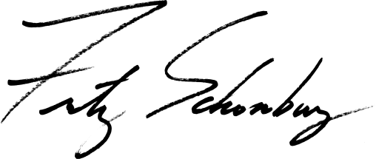

Fritz Schomburg, PhD
Founder and CEO

